A REPORT
on
Hospital Training - I
Submitted in Partial Fulfillment of the requirements
For the Degree of
Bachelor of Pharmacy
By
SATYAM YADAV
B.Pharm. III Year, V Semester
Roll No.: 2110180500072
Ambekeshwar Institute of Pharmaceutical Sciences (Lucknow)
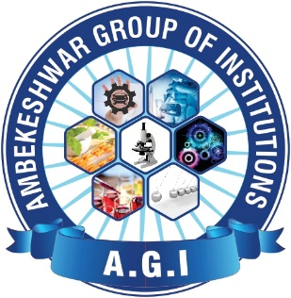
Under the Supervision of
CO-SUPERVISOR
Dr. Ila Dixit
Assistant Professor
AIPS, Lucknow

SUPERVISOR
Prof (Dr.) Savita Upadhyay
Director (Pharmacy)
AIPS, Lucknow


to the
Faculty of Pharmacy
Dr. A.P.J. Abdul Kalam Technical University, Lucknow
2023-2024

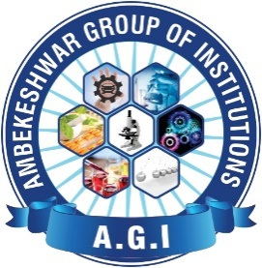

CERTIFICATE OF COMPILATION

This is to certify that this project report entitled “Hospital Training - I” submitted to Ambekeshwar Institute of Pharmaceutical Sciences, Lucknow, is a bonafide record of work done by “Satyam Yadav” (2110180500072) during the period of his/her study in Bachelor of Pharmacy in the academic year 2023-2024 in the Fifth semester of Third Year.

___________________________ __________________________
CO-SUPERVISOR
Dr. Ila Dixit
Assistant Professor
AIPS, Lucknow
SUPERVISOR
Prof (Dr.) Savita Upadhyay
Director (Pharmacy)
AIPS, Lucknow

__________________________
EXTERNAL EXAMINER

DATE: ……………………

COPYRIGHT

Declaration by the Candidate

I hereby declare that the Ambekeshwar Institute of Pharmaceutical Sciences, Lucknow shall have the rights to preserve, use and disseminate the report in print or electronic format for academic/ research purpose.

Place: Lucknow Student Name: Satyam Yadav
Date: Roll No.:2110180500072

DECLARATION BY THE CANDIDATE

This is to certify that the work presented in the report entitled “Hospital Training - I” has been carried out by me for the partial fulfillment of degree of ‘Bachelor of Pharmacy’ under the supervision of Prof (Dr.) Savita Upadhyay and Co-supervision of Dr. Ila Dixit of Ambekeshwar Institute of Pharmaceutical Sciences, Lucknow.
The report embodies results of the original work and studies carried out by me and the contents of the report have not formed the basis for the award of any degree/ diploma by any other University or Institution.
I also confirm that all the material which I have borrowed from other sources and incorporated in this report is duly acknowledged.

Place: Lucknow Student Name: Satyam Yadav
Date: Roll No.:2110180500072

CERTIFICATE BY THE CO-SUPERVISOR

This is to certify that the work presented in the report entitled “Hospital Training – I” submitted by Satyam Yadav (2110180500072) for the degree of ‘Bachelor of Pharmacy’ has been carried out in the Ambekeshwar Institute of Pharmaceutical Sciences, Lucknow under my guidance.

Place: Lucknow
Dr. Ila Dixit
Assistant Professor
AIPS, Lucknow
Date:

CERTIFICATE BY THE SUPERVISOR

This is to certify that the work presented in the report entitled “Hospital Training - I” submitted by Satyam Yadav (2110180500072) for the degree of ‘Bachelor of Pharmacy’ has been carried out in the Ambekeshwar Institute of Pharmaceutical Sciences, Lucknow under the co-supervision of Dr. Ila Dixit , Assistant Professor, Ambekeshwar Institute of Pharmaceutical Sciences, Lucknow.

Place: Lucknow
Prof (Dr.) Savita Upadhyay
Director (Pharmacy)
AIPS, Lucknow

Date:

ACKNOWLEDGEMENT

This is my proud privilege to be attached with RAM SAGAR MISHRA 100 BED COMBINED HOSPITAL, Lucknow. I have learned a lot during my training duration of 45 days and I am fortunate in getting an opportunity of working in this hospital. It helped to put the theoretical knowledge into practical experiences.

I would like to thanks Mr. Rajesh Jha sir, providing necessary training facilities and guidance during entire period of my training. I would also like to thanks all trainees and staffs, who helped me very much and without whose support and guidance it was impossible for me to complete the project successfully.

I would like to express my gratitude towards my parents & member of Ambekeshwar Institute of Pharmaceutical Sciences, Lucknow for their kind co-operation and encouragement which help me in completion of this project.

Place: Lucknow
Student Name: Satyam Yadav
Date

List of Tables

Table 1. Prescription Abbreviations……………………………………………………22

LIST OF FIGURES

Figure 1. Ram Sagar Mishra 100 Bed Combined Hospital…………………....……....…...01
Figure 2. Ram Sagar Mishra 100 Bed Combined Hospital………………………….….…02
Figure 3. Emergency Ward ………………………………………………………………..04
Figure 4. Ortho and Childcare Ward……………………………………………………….05
Figure 5. Pathology……………………………………………………………………..….07
Figure 6. Male-Female Ward .……………………………………………………….…….11
Figure 7. Department of Radiology………………………………………………………..12
Figure 8. Operations Theatre………………………………………………………………13
Figure 9. First Aid Essentials …………………………………………………………..….15
Figure 10. First Aid Kit…..………………………………………………………..…….…16
Figure 11. Types of Injections…………………………………………………..…………17
Figure 12. Disposal of used needles…………………………………………….…………18
Figure 13. Dressing ………………………………………………………….…………….19
Figure 14. Dressing Technique…………………………………………….………………20
Figure 15.Dispensing Process……………………………………………..……….……....23
Figure 16. Waste Segregation…………………………………………….…………….….25

LIST OF ABBREVIATIONS
OT: Operation Theatre
ED: Emergency Departments
JE: Japanese Encephalitis
HIV: Human Immunodeficiency Virus
CT: Computed Tomography
MRI: Magnetic Resonance Imaging
ER: Emergency Room
CD: Casually Department
RBC: Red Blood Cell
WBC: White Blood Cell
BP: Blood Pressure
GM/DL: Grams per deciliter
CU/MM: cubic millimeter
MG/DL: milligrams per deciliter
MM/HG: millimeters of mercury

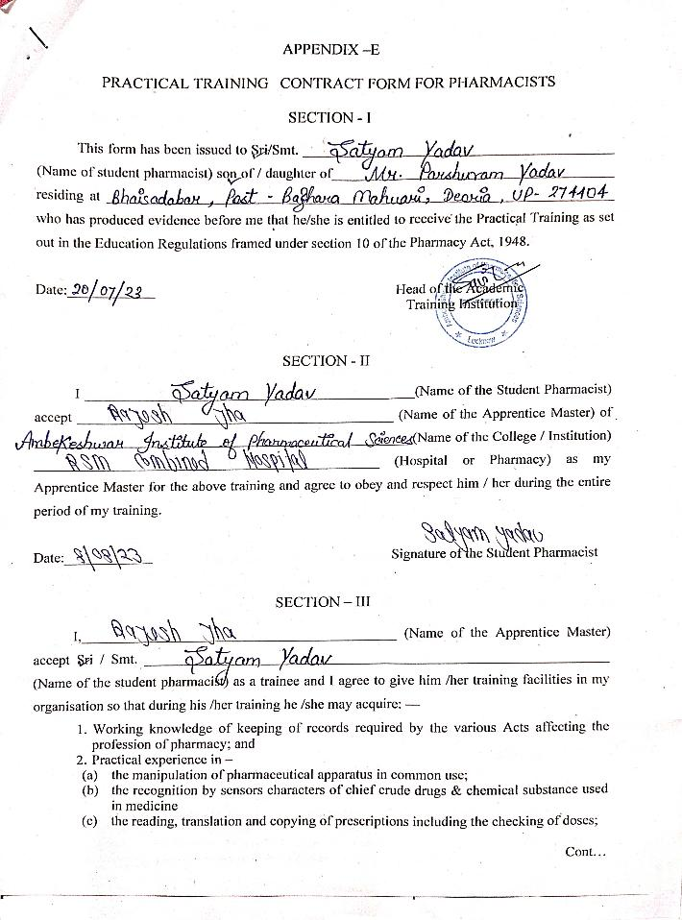
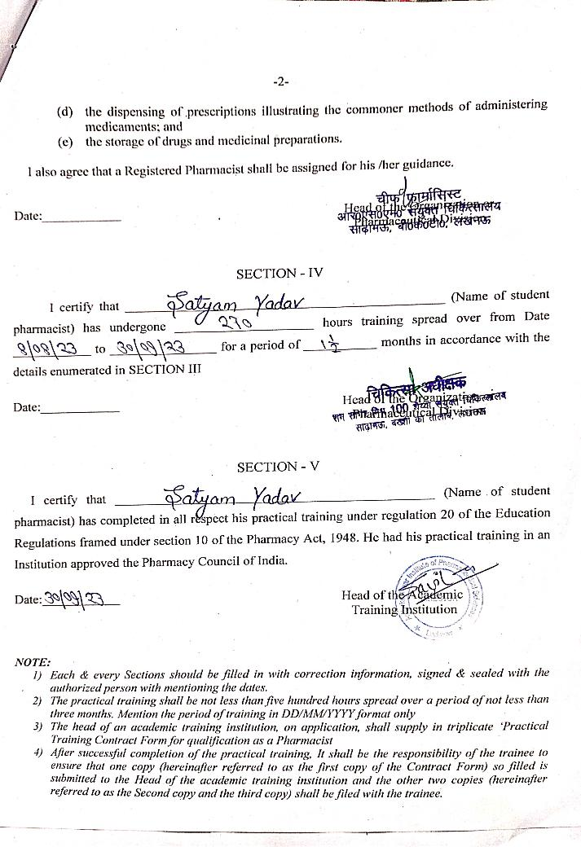
PRACTICAL TRAINING CONTRACT FORM FOR PHARMACISTS
CONTENTS
S. No | Particulars | Page No.
1. | Certificate of Compilation | ii
2. | Copyright | iii
3. | Declaration by the Candidate | iv
4. | Certificate by the Co-Supervisor | v
5. | Certificate by the Supervisor | vi
6. | Acknowledgement | vii
7. | List of Tables | viii
8. | List of Figures | ix
9. | List of Abbreviation | x
10. | Practical Training Contract Form for Pharmacists | xi-xii
11. | Introduction | 1 - 3
12. | Hospital Profile | 4 - 13
13. | Training Imparted | 14 - 26
14. | Observation | 27
15. | Result and Discussion | 28
16. | Conclusion | 29
17. | Bibliography | 30

INTRODUCTION
Introduction
Introduction
RAM SAGAR MISHRA 100 BED COMBINED HOSPITAL
RSM 100 bed combined hospital is situated in Sadhamau, Bakshi Ka Talab, Lucknow. The hospital is well known foe it’s satisfactory facilities. The hospital has a reputated image in the medical line. The hospital has very hard working medical and non-medical staff who are highly professional and disciplined in their duties. It is authorized by government of India. The hospital has proper sanitation and cleanliness so that the patients do not come in contact of any type of disease.
The hospital and its staff follow very strict rules and regulation. The hospital has many types of clinical and technical facilities so the patients would not suffer from any problem. There are regular health check ups are also done for the staff of the hospital. The hospital also provides residential area for the hospital staff and other members.
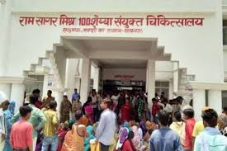
Figure 1- Ram Sagar Mishra 100 Bed Combined Hospital

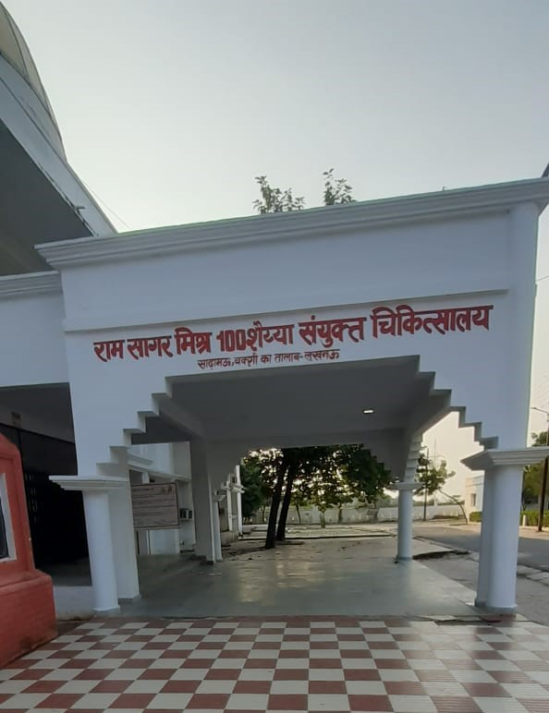
Introduction
Figure 2- Ram Sagar Mishra 100 Bed Combined Hospital
The hospital has separate departments divided for every different problem. Hospital has proper navigation signs and indicating boards to make the departments easier to find to the patients. The hospital provides proper facilities of 24 hours ambulance service and a medical team available to take care of the patients both day and night.
SECTIONS IN RAM SAGAR MISHRA 100 BED COMBINED HOSPITAL
- Emergency Ward
- Ortho and child care ward
- Pathology
- Pharmacy
- Radiology
- OT (Operation Theatre)
- Male-Female ward

EMERGENCY WARD
Hospital Profile
- An emergency ward is a dedicated area in a hospital that is organized and administered to provide a high standard of emergency care to people who are in need of, acute or urgent care including hospital admission.
- Emergency departments (ED) are an integral part of hospitals and medical practices and provide the best medical or surgical care to patients arriving in need of immediate care.
- EDs serve as the first point of contact, and people of nearly every age are given particular medical care based on their injury or illness.
- Emergency departments are well equipped with all the modern and essential equipment and accessories to render timely acute, emergency, trauma care services.
- A typical ED consists of nurses, doctors, and physicians who address a wide range of medical issues such as fatal injuries.
- Emergency care 24 hours a day is provided.
- At least one experienced physician is always available in the ED to take the charges of emergency cases.
Figure 3- Emergency Ward

ORTHO AND CHILD CARE WARD
Hospital Profile
- Orthopaedics is a medical specialty that focuses on the diagnosis, correction, prevention, and treatment of patients with skeletal deformities - disorders of the bones, joints, muscles, ligaments, tendons, nerves and skin. These elements make up the musculoskeletal system.
- Orthopaedists use medical, physical and rehabilitative methods as well as surgery and are involved in all aspects of heath care pertaining to the musculoskeletal system.
- Orthopaedists treat an immense variety of diseases and conditions, including fractures and dislocations, torn ligaments, sprains and strains tendon injuries, pulled muscles and bursitis ruptured disks, etc.
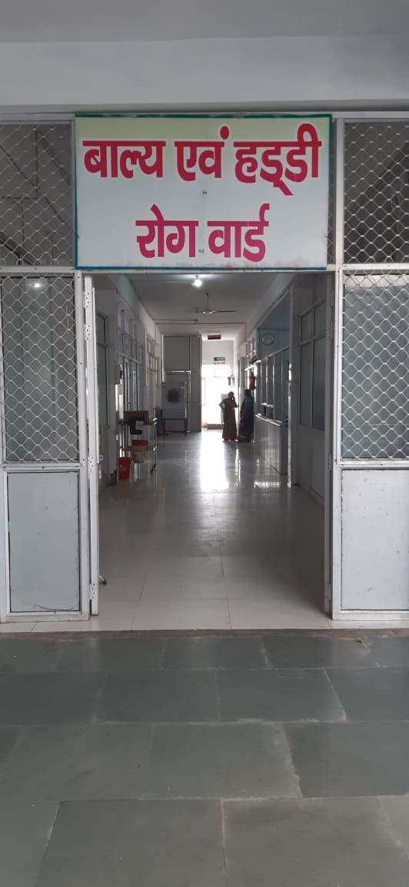
Figure 4- Ortho and Childcare Ward
Pediatric Ward
Hospital Profile
The pediatric ward staff are responsible for the daily management of conditions affecting children, from birth to 18 years of age.
- In child care ward, children and adolescents are treated who are suffering and are in need of specialised care.
- Specialized doctors and nurses are available for treatment of a varied range of diseases in children and for providing timely injections or doses.
- Most of the child patients who come for the treatment are suffering from JE (JAPANESE ENCEPHALITIS).

PATHOLOGY
Hospital Profile
- Pathology involves the examination of tissues, organs, bodily fluids, and autopsies in order to study and diagnose disease.
- Pathology also includes the related scientific study of disease processes whereby the causes, mechanisms and extent of disease are examined.
- Pathologists specialize in a wide range of diseases including cancer and the vast majority of cancer diagnoses are made by pathologists.
- In common medical practice, general pathology is mostly concerned with analyzing known clinical abnormalities that are markers or precursors for both infectious and non-infectious disease, and is conducted by experts in one of two major specialties, anatomical pathology and clinical pathology.
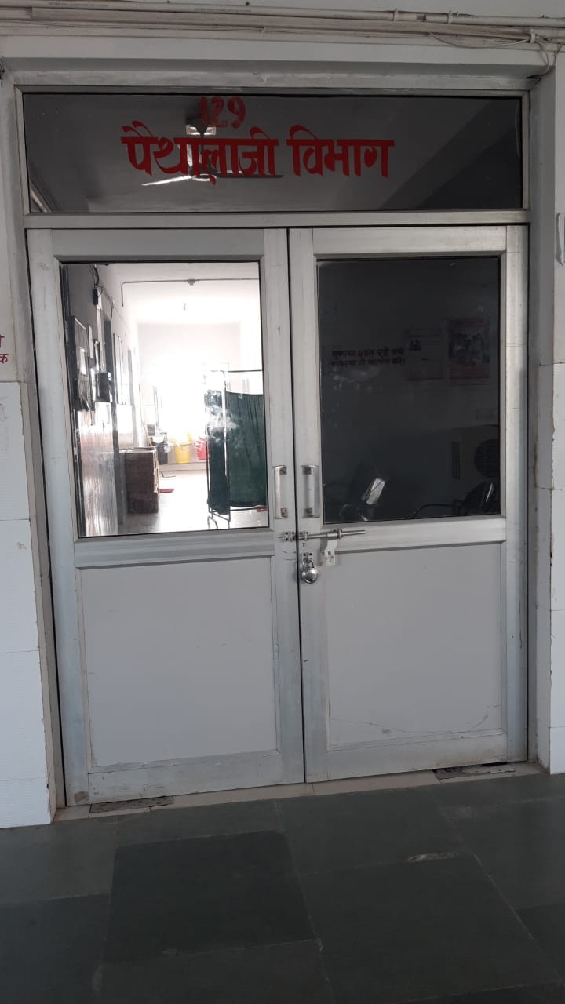
Figure 5- Pathology
PHARMACY
Hospital Profile
- Pharmacy is available in the hospital that have stock of a large range of medications.
- It typically provides medications for the hospitalized patients only and are not retail establishments.
- Some hospitals do have retail pharmacies with in them, which sell over the counter as well as prescription medications to the public, but these are not the actual hospital pharmacy.
- It also helps patients to understand their medications and how to take them.
- Pharmacists acquire expertise in the storage of data, distribution, and inventory control functions, and the management of data for drug histories, patient records, quality assurance programs, and drug information services.
The primary functions of Hospital Pharmacy are:
- Selection of reliable suppliers
- Storing and dispensing of Drugs
- Maintenance of manufacturing records
- Quality control of purchased and manufactured products
- Expecting and knowing the hospital demands

Objectives Of Hospital Pharmacy
1. To professionalize the functioning of the pharmaceutical services in hospital.
2. To ensure availability of the required medication at an affordable cost at the
required time.
3. To plan, organize and implement the policies of the pharmacy.
4. To perform functions of management of material, purchase, storage of essential medicines.
5. To maintain strict inventory of all items received and issued.
6. To counsel the patient, medical staff, nurses and others involved in patient care on the use of drugs, possible side effects, toxicity, adverse effects, drug
interactions etc.
7. To serve as a source of information on drug utilization.

Five Principles of Pharmacy
1. FIFO – First In First Out
2. LASA – Look Alike Sound Alike
3. LIFO – Less Life In First Out
Hospital Profile
4. VED – Vital Essential Desirable
5. GAAP – General Accounting Principles In Pharmacy

Care While Storing The Medicine
1. Narcotics drugs in safe custody (double lock).
2. Safe Refrigeration of medicines requiring certain temperature.
3. Have a ‘Master Chart’ at the entrance of medical store, showing the layout of racks, almirahs in store with list of medicines.
4. Display Emergency Drug List.
5. Display Essential Drug List.
6. Drug Formulatory of EDL on display (circulate to all departments).
7. Display expiry drug list mentioning date of expiry, batch number and quantity of the drug.
8. Do not keep drugs with direct contact of floor or direct sunlight near the window.
9. Keep inflammable drugs/ chemicals separate and away from other drugs.

Quality Tool For Improvement Of Process Of Purchasing And Maintaining Stock Of Drugs As PEREDL List

PDCA CYCLE

PLAN
- Training should be organized for staff to operate online system.
- Availability of budget to purchase drugs in case of shortage or delay.
- Staff as per requirement to avoid the overload.

DO
- Impart Training.
- Apply for budget to purchase medicine from local store.
- Manage timely order and transportation of drugs.

CHECK
Hospital Profile
- Availability of drugs.
- Time management of placing order and transportation of drugs.

ACT
- Periodic training.
- Maintaining adequate stock of drugs.

END RESULT: Drug shortage will be handled by this approach.

MALE-FEMALE WARD
Hospital Profile
A general ward is a large room, where people who need medical treatment and not suffering from any chronic disease stay.
FEMALE GENERAL WARD
This ward is dedicated to the care of female patients. Nurses are responsible for the daily management of acute and chronic medical conditions such as malaria, hypertension, diabetes mellitus, HIV, gastrointestinal conditions among others. Patients are admitted to the unit directly from the emergency department. The unit has accessories for oxygen therapy, suction and nebulizing of patients who may be in acute respiratory distress.

MALE GENERAL WARD
Admissions, monitoring and oxygen therapy are done at the male emergency ward. Staff manage conditions such as malaria, hypertension, diabetes, cerebrovascular accidents, renal failure among others. Nurse’s activities include participation in vital sign assessment and recording, medication administration, health education, wound dressings and ward rounds with physicians and physician assistants.

Figure 6 – Male-Female Ward

RADIOLOGY DEPARTMENT
Hospital Profile
It is a medical specialty that uses imaging to diagnose and treat diseases seen within the body. Radiologists use a variety of imaging techniques such as X-ray, ultrasound, computed tomography (CT), and magnetic resonance imaging (MRI) to diagnose and/or treat diseases.
- X-rays – used to look through tissue to examine bones, cavities and foreign objects. May be used with contrast agents to provide a live motion image, e.g., fluoroscopy to image the digestive system, or angiography to investigate blood vessels
- CT (computed tomography) – provides cross-sectional views (slices) of the body allowing disease to be identified and localised
- Ultrasound – uses high frequency sound. This technique is widely used in obstetrics, gynaecology and paediatrics and for patients with abdominal, vascular or musculoskeletal conditions
- MRI (magnetic resonance imaging) – provides high quality imaging of body parts without the need for radiation.
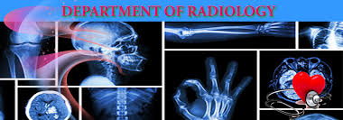

Figure 7 – Department of Radiology

OPERATIONS THEATRE
Hospital Profile
An operating theatre is where certain surgical procedures which means operations that involve cutting into and working inside a patient’s body take place. Complicated operations can last many hours.
The stages of an operating theatre;
Operations normally take place in four stages, which all require specialist staff:
1. pre-operative stage is when patients are informed about and prepared for the operation about to take place, by restricting their diet.
2. Anaesthetic stage is when the patient is either ‘put to sleep’ under general anaesthetic or has part of their body numbed under local anaesthetic.
3. Surgical stage is when the operation is performed in the operating theatre
4. Recovery stage is when the patient is transferred to a ward for further care and treatment.
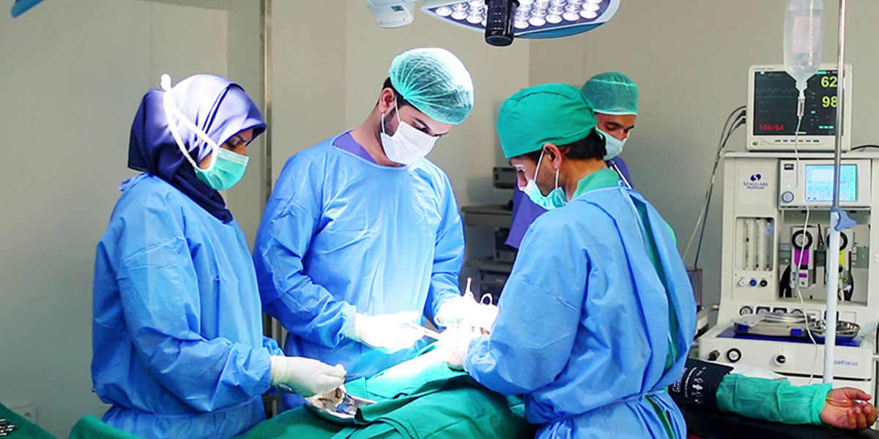

Figure 8 - Operations Theatre

HOSPITAL INTERNSHIP ACTIVITY
Training Imparted
Hospital Internship Activities include –
1. First Aid Treatment
2. Injections
3. Dressing
4. Prescription
5. Dispensing Procedure
6. Diagnostic Report
7. Patient Observation Chart

FIRST AID TREATMENT
Training Imparted
First Aid is immediate medical assistance to an ill or injured until the illness or injury is fully dealt with. It generally consists of a series of simple, potentially life-saving steps that an individual can be trained to perform with minimal equipment.
First aid procedure
- Laying the person flat.
- Opening their airway and assessing for breathing.
- Loosening any restrictive clothing around their neck or their waist.
- Consciousness is usually quickly regained with these first aid measures.
- If the person remains unconscious, check for breathing again and, provided that they are breathing, put them into the recovery position. Call an ambulance and refer for further assessment as needed.

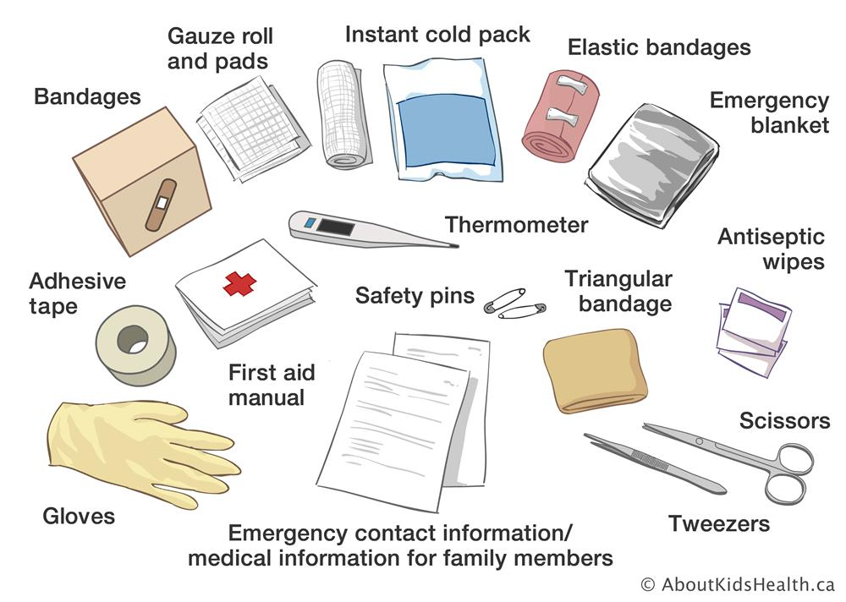

Figure 9 - First Aid Essentials
The person should be encouraged to use the principles of 'paying the PRICE' and 'avoiding HARM' for the first 48-72 hours after the injury.
Training Imparted
- Protection: from further injury.
- Rest: for the first 48-72 hours after injury, activity should be avoided. The use of crutches can be considered for lower limb injuries.
- Ice: a specialized ice pack wrapped in a cloth can be applied for 15-20 minutes every 2-3 hours for the first 48-72 hours after injury.
- Compression: helps to reduce swelling. An elastic bandage can be applied around the affected limb. Remove at night. Ensure that the bandage is not too tight.
- Elevation: as far as possible, elevate the injured area above the level of the heart for the first 48-72 hours, ensuring that it is comfortably supported.

Avoid HARM for the first 72 hours after the injury:
- Heat: including heat packs, hot baths, saunas.
- Alcohol: this can increase swelling and bleeding.
- Running: or other forms of exercise.
- Massage: this can increase swelling and bleeding.

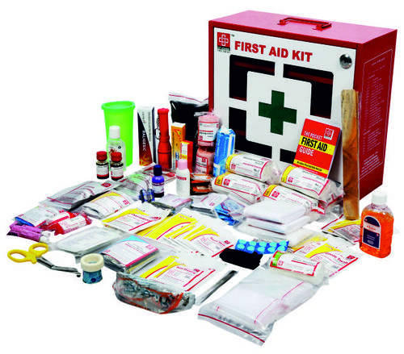
Figure 10 - First Aid Kit
METHODS OF INJECTIONS
Training Imparted
An injection is a way of administering a liquid to a person using a needle and syringe.
The four most frequently used types of injection are:
- Intravenous (IV) injections. An IV injection is the fastest way to inject a medication and involves using a syringe to inject a medication directly into a vein.
- Intramuscular (IM) injections. IM injections are given deep into a muscle where the medication is then absorbed quickly by surrounding blood vessels.
- Subcutaneous (SC) injections. SC injections are injected into the innermost layer of the skin called the subcutis or hypodermis, which is made up of a network of fat and collagen cells. SC injections are also known as ‘subcut’ or ‘SQ’ injections. These injections work more slowly than an IV or IM injection because the area does not have such a rich blood supply.
- Intradermal (ID) injections. ID injections are given directly into the middle layer of the skin called the dermis. This type of injection is absorbed more slowly again than IV, IM or SC injections.
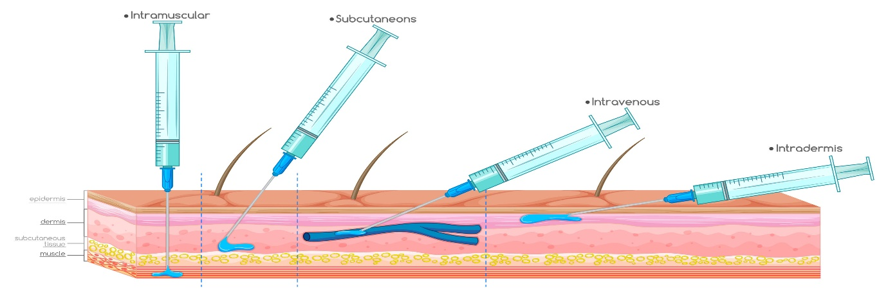
Figure 11 - Types of Injections
Technique of needle use
Proper needle use is important to perform injections safely, which includes the use of a new, sterile needle for each injection. Needles should not be shared between people, as this increases risk of transmitting blood-borne pathogens. In addition, it is not recommended to reuse a used needle to pierce a medication bag, bottle, or ampule designed to provide multiple doses of a medication, instead a new needle should be used each time the container must be pierced. Aseptic technique should always be practiced when administering injections. This includes the use of barriers including gloves, gowns, and masks for health care providers. It also requires the use of a new, sterile needle, syringe and other equipment for each injection, as well as proper training to avoid touching non-sterile surfaces with sterile items.
Training Imparted
Disposal of used needles
Used needles should be disposed of in specifically designed sharp containers to reduce the risk of accidental needle sticks and exposure to other people. In addition, a new sharp container should be begun once it is 3⁄4 full. A sharps container which is 3⁄4 filled should be sealed properly to prevent re-opening or accidental opening during transportation.

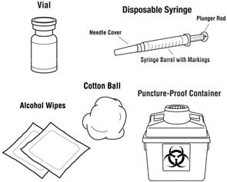
Figure 12 - Disposal of used needles

DRESSING
Training Imparted
A dressing is used to protect a wound and prevent infection, but also to allow healing. A dressing should be large enough to totally cover the wound, with a safety margin of about 2.5 cm on all sides beyond the wound. A sterile dressing may be used to control bleeding from a major wound or to absorb any discharge from a minor wound.
A bandage is used in combination with a dressing where a wound is present. A roller bandage is used to secure a dressing in place. A triangular bandage is used as an arm sling or as a pad to control bleeding. It may also be used to support or immobilise an injury to a bone or joint or as improvised padding over a painful injury. A tubular gauze bandage is used to retain a dressing on a finger or toe.

The seven most commonly used wound dressings-
1. Hydrocolloid- Hydrocolloid dressings are impermeable to bacteria, which is what makes them so effective at preventing infections. They are also long-lasting, biodegradable, and easy to apply.
2. Hydrogel- It can be used for a range of wounds that are leaking little or no fluids. Hydrogel can also be used for second-degree burns and infected wounds.
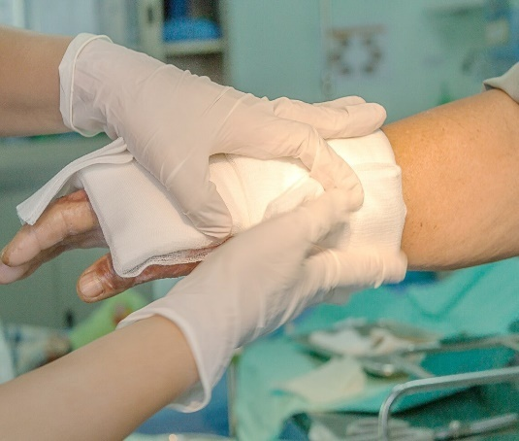
Figure 13 - Dressing
3. Alginate- These dressings absorb excess liquid and create a gel that helps to heal the wound or burn more quickly. These dressings require changing around every two days, sometimes more, due to the amount of liquid that they absorb and the nature of the wound. Changing them too often could cause too much dryness or could lead to bacteria penetrating the wound. These should only be used for wet wounds with high liquid drainage; else they can hinder healing by drying out wounds too quickly.
Training Imparted
4. Collagen- Collagen dressings can be used for chronic wounds or stalled wounds, pressure sores, transplant sites, surgical wounds, ulcers, burns, or injuries with a large surface area. Collagen dressings encourage the wound healing process in a range of ways; these include by helping to remove dead tissue, aiding the growth of new blood vessels, and helping to bring the wound edges together, effectively speeding up healing.
5. Cloth dressings- These are the most commonly used dressings, often used to protect open wounds or areas of broken skin. They are suitable for minor injuries such as grazes, cuts or areas of delicate skin.These dressings come in all shapes and sizes, from small coverings for fingers to larger ones for wounds across wider areas of the body. As well as pre-cut dressings, these also come in a roll option that is made to be cut to size.
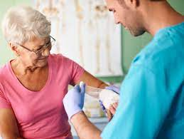
Figure 14 - Dressing Technique
PRESCRIPTION
Training Imparted
Prescription is defined as a written or in any other form document issued by a Registered Medical Practitioner or any other licensed practitioners. Prescription is a way of communication between physician and pharmacist in which physician and other healthcare professionals authorized pharmacist to dispense or compound a specific prescription drug for a specific patient or caretaker. It is often abbreviated ℞ or Rx.
Under Drug and Cosmetic Act, 1945, A Prescription should have following particulars:
“For the purposes of clause (9) a prescription shall
(a) be in writing and be signed by the person giving it with his usual signature and be dated by him;
(b) specify the name and address of the person for whose treatment it is given, or the name and address of the owner of the animal if the drug is meant for veterinary use;
(c) indicate the total amount of the medicine to be supplied and the dose to be taken.”

Contents of the Prescription :
- Prescribers office information: Name, qualification, address & Regn. No.
- Patient information: Name & address, Age, Sex, Ref. No.
- Date
- Rx Symbol (Known as Superscription Part)
- Medication Prescribed (Known as Inscription Part)
- Dispensing directions to Pharmacist (Known as Subscription Part)
- Directions for patient to be placed on label
- Refill, Special labeling and /or other instructions
- Prescriber’s signature and license (or) Drug Enforcement Agency (DEA) number as required.
SOME PRESCRIPTION ABBREVIATIONS
Training Imparted
a.c | Before meal
a.m | morning
Aq. | water
Aurist | ear-drops
b. | twice
b.i.d | twice a day
Caps | a capsule
Charts | Powder papers; divided powders
c.c. | With food; with meals
H | At the hours of
H.s. | At bedtime
n. | At night
Narist. | Nasal drops
o.m. | Every morning
q.i.d | Four times a day

Table 1 - Prescription abbrevations

DISPENSING PROCESS
Training Imparted
The consistent, repeated use of good dispensing procedures is vital in ensuring that errors are detected and corrected at all stages of the dispensing process. The term dispensing process covers all activities involved, from receiving the prescription to issuing the prescribed medicine to the patient.
The development and use of written standard operating procedures (SOPs) for the dispensing process will improve consistency and quality of work and can be used for training and reference. The framework for such SOPs may be based on the six major areas of activity:
1. Receive and validate the prescription
2. Understand and interpret the prescription
3. Prepare and label items for issue
4. Make a final check
5. Record the action taken
6. Issue medicine to the patient with clear instructions
and advice

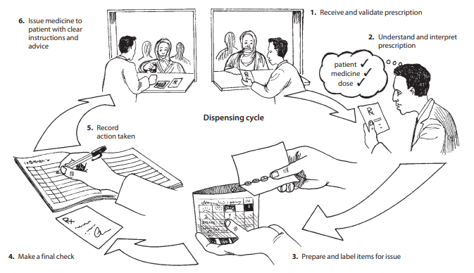
Figure 15 - Dispensing Process
PHYSIOLOGICAL PARAMETERS
Training Imparted
1. pH of Blood:- 7.35-7.45
2. Hemoglobin
a. 13-18gm/dl in adult male
b. 12-16gm/dl in female
c. 9-15gm/dl in children
3. RBC Count (Red Blood Cell)
a. 4.5-5.5 microliter in male
b. 3.5-5.5 microliter in female
4. WBC Count (White Blood Cell) 4000-11000/cu mm
5. Platelet or Thromocytes count 1,50,000-4,00,000
6. Clotting time 2-6 min
7. Bleeding time 2-5 min
8. Blood Sugar Level 80-120mg/100ml
9. Blood cholesterol 150-250mg/100ml
10. Blood urea 8-26 mg/dl
11. Creatinine 1-2mg/dl
12. Sperm count 60-150 million per ml
13. Heart rate 70-80 beats/min
14. Blood pressure 80-120mm /Hg

WASTE MANAGEMENT IN HOSPITALS
Training Imparted
In hospitals there are medical waste such as infectious items, chemicals, expired pharmaceuticals, radioactive items, and sharps (used needles, lancets etc.) are hazardous and, if not properly disposed or treated, can be lethal and a threat to the environment.
Color-Code Containers and Waste Bins
There are various types of medical wastes which are necessary to be disposed. Every waste from the hospital has separate identification and have different methods for their disposal. Segregating medical wastes based on their type helps ensure that each waste is discarded, transported, and destroyed properly. Waste bin color coding in hospitals help healthcare staff easily segregate waste and identify which waste goes to which container to help and prevent issues arising from random or improper disposal.
Healthcare waste segregation is done ideally at the very first opportunity to avoid hazardous hospital waste from getting mixed with regular waste.

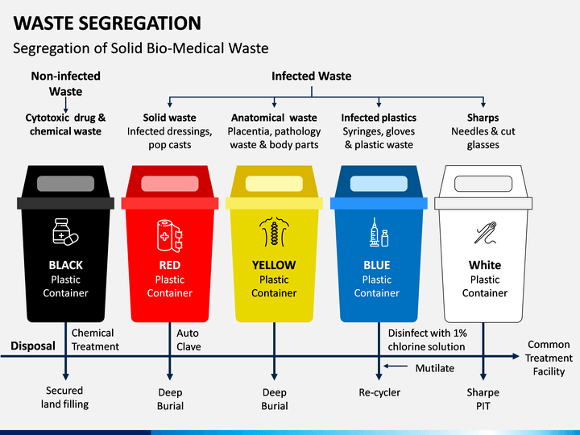
Figure 16 - Waste Segregation
These are easy to use and they help get more things done in shorter period of time.
Training Imparted
Monitoring checklists also help ensure that people get their daily, weekly, and monthly task done on time.
These are just some of practices that can be done to ensure proper medical waste management in the healthcare facility:
- It minimizes the spread of infectious and reduces the risk of accidental injury to staff, patients, visitors, and the community.
- It reduces the likelihood of contamination of the soil or ground water with chemicals or micro-organisms.
- It attracts fewer insects and rodents and does not attract animals.
- It helps provide an aesthetically pleasing atmosphere.
OBSERVATION
Observation
Because of this, I came to the conclusion that the hospital is a place where people of all kinds go to bring their problems, which they trust the medical staff to handle. Work can be done in the hospital by maintaining a clean environment.
The medical staff members and Doctors all provide the patients a hostile and amusing treatment while paying attention to their problems.
Every department operates in a distinctive way, and at the end of the day, it completes the entire task.
Without any disrespect, patients receive their injections or pills and they get treatment right away. They can always rely on the nursing team to take care of their requirements. Hospitals ought to use this kind of approach.

RESULT AND DISCUSSION
Result And Discussion
45 Days hospital training has been completed as per the university curriculum and the work was performed in different section of the hospital like emergency, IPD, OPD, dispensary and store.
The hospital is the most interesting part of the university syllabus, it provides us a huge explore to learn and utilize all the knowledge.

CONCLUSION
Conclusion
The training in a hospital gives us a conclusion that the training in the hospital was really necessary as it now only helped us to see a hospital operates, but it also help me to learn basic function of it like first aid care how to give injection and dispensing of drugs etc.
The conclusion drawn out can be that I have finally learned as to how important role a hospital plays in people lives and that the hospital staff can go to save them since it’s their duty. Since Ram Sagar Combined Hospital receives only 1 rupee per patient, it also shows us their good deed towards mankind and to their service.
BIBLIOGRAPHY
Bibliography

Pharmacy Department- https://en.m.wikipedia.org/wiki/Pharmacy
Emergency Department- https://en.wikipedia.org/wiki/Emergency_department
OPD- https://byjus.com/full-form/opd-full-form
General Ward- https://en.wikipedia.org/wiki/General_Ward
Pathology Lab- https://www.healio.com
Dressing department- https://en.wikipedia.org/wiki/Dressing_(medical)
Diagnostic report- https://www.ibm.com/docs/en/tnpm
Dispensing- https://www.bccnm.ca/RN/learning/medication/Pages/dispensing.aspx
Injection- https://www.medicalnewstoday.com/articles/types-of-injections#side-effects
Prescription- https://www.pharmaguideline.com
Ortho and childcare ward- https://en.wikipedia.org/wiki/Child_care
Pediatricward- https://www.sciencedirect.com/topics/nursing-and-health-
Male female ward- https://www.mmh.mw/male-and-female-ward-and-surgical-services/
Radiology department- https://www.sciencedirect.com/topics/nursing-and-health-
Operation theatre- https://en.wikipedia.org/wiki/Operating_theater

